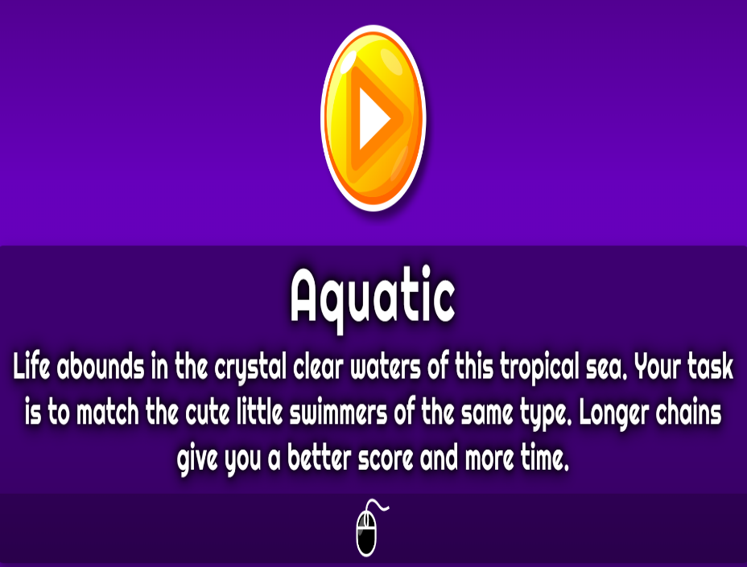



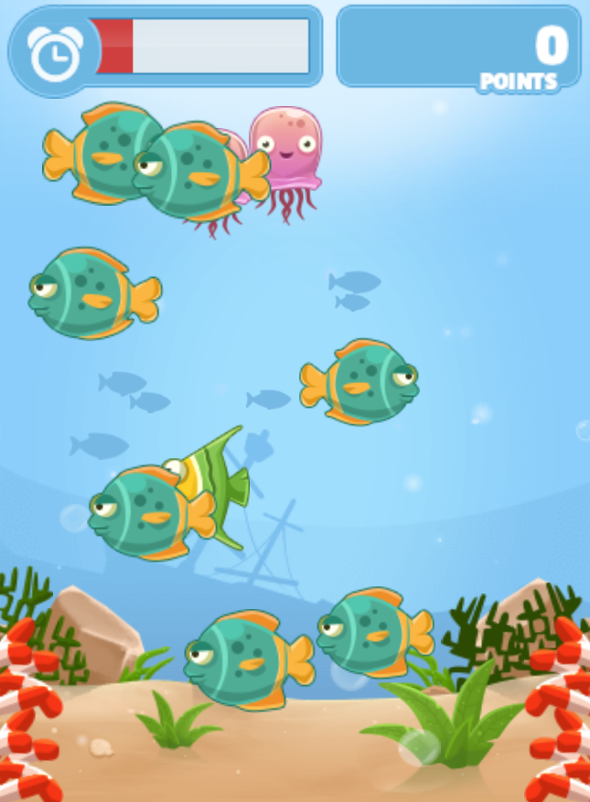

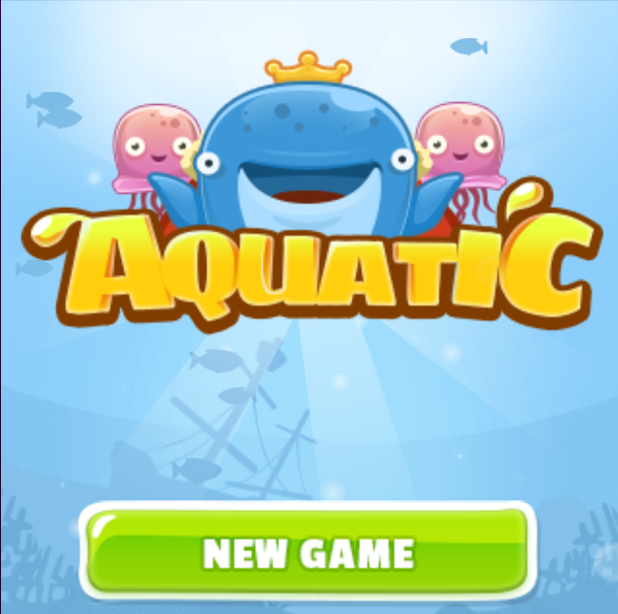

“AQUATIC”

Submitted by:

Cedo, John Benedict C.

Submitted to:

MR. Rn Santos

HCI INSTRUCTOR

Genre: Adventure, 2D slide

Target: Ages 7 and below

Rating: Rated EC (early childhood)

Number of players: Single player

Platform: PC

GAMEPLAY:

A player must collect a fish in order for the time to be increase. A player has only 1 life so that the player must get a fish faster. If you cannot get a fish in the remaining time the game will be over. Its task is to match the cute little swimmers of the same types.

STORY:

Life bounds in the crystal clear water of this tropical sea. You must match the cute little swimmers of the same type. Longer chains give you a better score and more time.